genero, artículos definidos, artículos indefinidos (p. 66)
In Spanish, every noun (person, place, etc.) has an assigned gender. Gender will never change.
Every noun is either ______________________________ or ______________________________.
Comprehension check: What are some things that take a specific gender in English?

Gender rules (99% of the time)
Masculine words Feminine words
- end with “-o” - end with “-a”
- libro, chico, helado galleta, pizza
- end with “-l” - end with “-dad”, “-tad”
-mineral -sociedad, voluntad
- exceptions - end with “-ción”
- mapa, día, -información, estación
-shorted originally feminin words
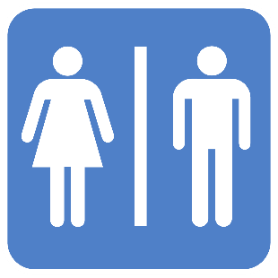
-foto (fotografía), bici (bicicleta)
-nouns referring to women
-mujer, madre
-ends with “-z” or “ces”
-lápiz, luz, luces, lápices

Comprehension Check: Write “M” if the following words are masculine. Write “F” if the following words are feminine.

- ________ chico
- ________ jugo
- ________ refresco
- ________ lápiz
- ________ mapa
- ________ Mujer
- ________ Hombre
- ________ Voluntad
- ________ Foto
- ________ Computación
- ________ Normalidad
- ________ Contracción
- ________ Día
- ________ Mineral
- ________ Coral
- ________ papa
- ________ tarea
- ________ teléfono

Artículos definidos (p. 14)

Definite Articles translate as “the” in English.
In Spanish, there are 4 ways of saying “the”.
Definite Articles come before a noun.
They agree with the noun in gender and number.

Masculine Feminine

Singular

Plural
Ej.
Chico el chico los chicos chica la chica las chicas
Boy the boy the boys girl the girl the girls

Practice:

- ________ chico
- ________ jugo
- ________ refresco
- ________ lápiz
- ________ mapa
- ________ Mujer
- ________ Hombre
- ________ Voluntad
- ________ Foto
- ________ prueba

Artículos indefinidos (p. 14)
Singular Indefinite Articles translate as “a”, “an” in English.
Plural Indefinite Articles translate as “some” in English
Masculine Feminine

Singular

Plural
Chico un chico unos chicos chica una chica unas chicas
Boy a boy some boys girl a girl some girls

