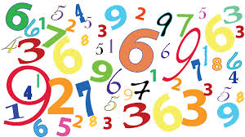
Los Números (30)
(write the numbers in Spanish)

0
1
2
3
4
5
6
7
8
9
10
11
12
13
14
15
16
17
18
19
20
21
22
23
24
25
26
27
28
29
30
31
40
50
60
70
80
90
100

Los números:
In Spanish, the numbers 16-29 can be written separate or together:
separate: together:
16 = diez y seis dieciséis
19 = diez y nueve diecinueve
22 = veinte y dos veintidós
29 = veinte y nueve veintinueve
Practice:
Separate together
17 __________________________ __________________________
21 __________________________ __________________________
28 __________________________ __________________________

