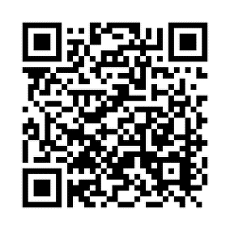
Basic Conversation

Watch the video and write the correct Spanish translations of the following words and phrases. Don’t forget to add accent marks when neeed! To find the video, use the QR reader to the right or the link at the bottom of the page. (You can also find the video on my teacher website.)

Hello. = ______________________________________________
How are you? = __________________________________________
I am fine. = ______________________________________________
I am bad. = ______________________________________________
I am ok. = ______________________________________________
Thanks. = ______________________________________________
And you? = ______________________________________________
What is your name? = ______________________________________________
My name is… = ______________________________________________
Where are you from? = ______________________________________________
I am from… = ______________________________________________
Nice to meet you. = ______________________________________________
Likewise./ Nice to meet you too. = ______________________________________________
Bye. = ______________________________________________
See you later. = ______________________________________________
¡Vamos a practicar! (Let´s practice!)
Write an appropriate Spanish phrase for each of the following scenarios.
1. Your friend just asked you how you are doing
_________________________________________________________________________________
2. A new student just arrived to your class
_________________________________________________________________________________

CHALLENGE: What does “me llamo” literally mean? ______________________________________________

http://www.senorjordan.com/2014/02/basic-conversation-entire-conversation/

